Accessing and Analyzing Data by Using Amazon S3

Lab overview and objectives
In this lab, you will learn how to upload, encrypt, compress, and secure data as a .csv file in Amazon Simple Storage Service (Amazon S3). Then, by using the S3 Select feature, you will use SQL statements to query data in Amazon S3 without needing to set up a database.
After completing this lab, you should be able to do the following:
- Create an AWS CloudFormation template and deploy it as a stack to create an S3 bucket.
- Load data into an S3 bucket.
- Use S3 Select to query a .csv file that is stored in an S3 bucket.
- Modify the encryption properties and storage type for an S3 object.
- Upload a compressed version of a dataset to Amazon S3.
- Review an AWS Identity and Access Management (IAM) policy that is used by team members to access the data.
- Test a team member's restricted access to the data by using the AWS Command Line Interface (AWS CLI).
Duration
This lab will require approximately 60 minutes to complete.

AWS service restrictions
In this lab environment, access to AWS services and service actions might be restricted to the ones that are needed to complete the lab instructions. You might encounter errors if you attempt to access other services or perform actions beyond the ones that are described in this lab.

Scenario
In this lab, you will assume the role of a member of the data science team. The team includes the following members:
- Sofía: The team manager
- Paulo: Focuses on collecting data, hosting the data, and building the infrastructure to support the data pipeline
- Mary: Focuses on analyzing data and getting insights from it by using data analytics and machine learning (ML) tools
You will build a proof of concept (POC) to use Amazon S3 to accomplish some of the team's data analytics tasks. You are quite familiar with Amazon S3 from your previous work in the AWS Cloud.
One common task that the team does is use SQL queries on large, compressed, and encrypted .csv data files to understand the data. Currently, the team moves the .csv files to a SQL database, where they can then query the data. The security team is responsible for managing backup and locking (access control) for the files, and the team has manual procedures and rules in place to manage the data's lifecycle. These tasks are well-documented, and the team is familiar with them, but the tasks are time-consuming and prone to errors. One of your goals is to reduce the time that is needed to analyze this data.
You want to experiment with the S3 Select feature, which you can use to perform SQL queries directly on .csv files that are stored in an S3 bucket. You will use a customer contact information dataset in your POC. For more information about Amazon S3, see the Amazon Simple Storage Service Documentation.
When you start the lab, the environment will contain the resources shown in the following diagram. For this lab environment, the original data source is an S3 bucket that exists in another AWS account.
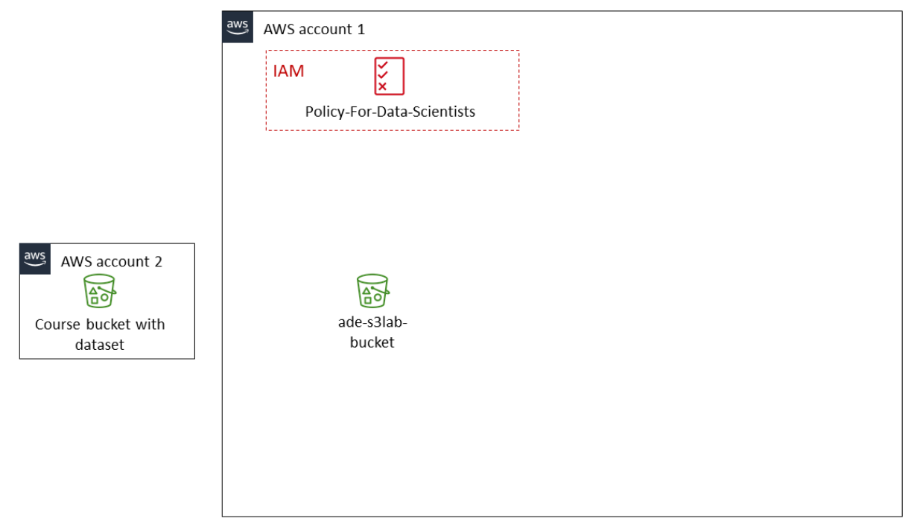
The lab environment is created with a CloudFormation template that is deployed when you launch the lab in Vocareum. The deployed CloudFormation stack creates an S3 bucket named ade-s3lab-bucket and an IAM policy named Policy-For-Data-Scientists.
Tip: To review the CloudFormation template that built this environment, navigate to the CloudFormation console. In the navigation pane, choose Stacks.
By the end of the lab, you will have created the additional architecture shown in the following diagram. The table after the diagram provides a detailed explanation of the architecture and the tasks that you will complete while working through the lab.
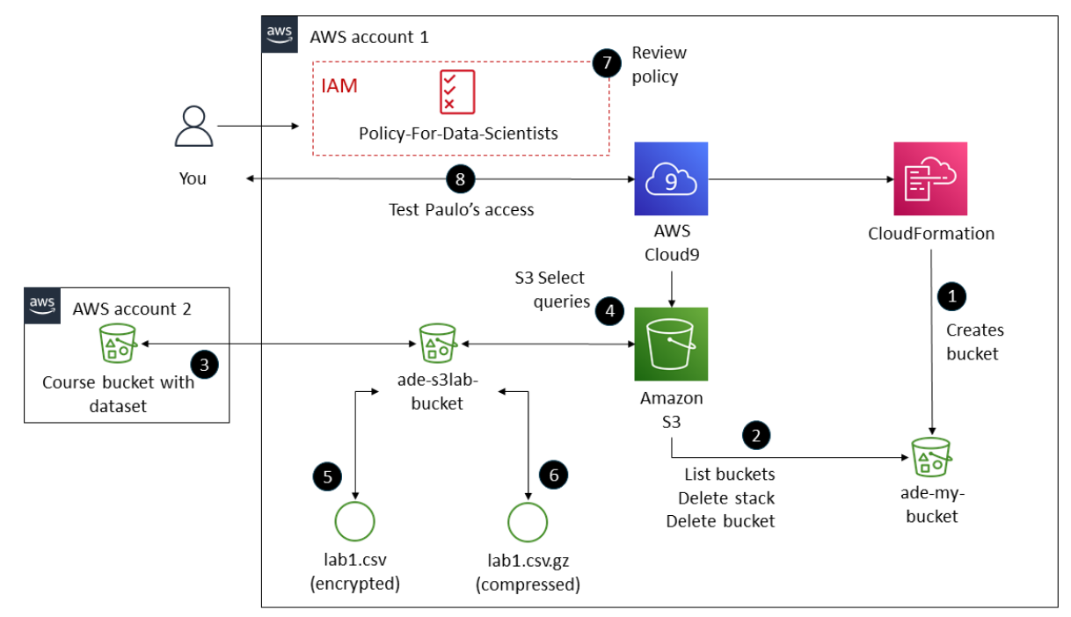

Numbered Task | Detail
1 | You will create a CloudFormation template to create a bucket named ade-my-bucket.
2 | You will also learn how to use the aws s3 list-buckets command to interact with an S3 bucket. Then, you will use the aws cloudformation delete-stack command to delete the stack and the bucket.
3 | You will retrieve the original dataset by using the Wget command. Then, you will use the aws s3 cp command to copy the dataset to an S3 bucket named ade-s3lab-bucket.
4 | You will use the S3 Select feature to query the dataset as a file stored in Amazon S3. You will build these queries as SQL statements.
5 | You will encrypt the dataset's S3 object file (lab1.csv) by using Amazon S3 managed keys (SSE-S3) and modify it's storage type.
6 | You will also compress an S3 object file (lab1.csv.gz), then compare the size of the gzip and zip files.
7 | You will review the IAM policy named Policy-For-Data-Scientists. This policy is attached to an IAM group that your teammate Paulo is assigned to.
8 | You will use this policy to test Paulo's access to the dataset and his ability to modify the object's properties.

Accessing the AWS Management Console
- At the top of these instructions, choose Start Lab.
  - The lab session starts.
  - A timer displays at the top of the page and shows the time remaining in the session.
Tip: To refresh the session length at any time, choose Start Lab again before the timer reaches 00:00.
  - Before you continue, wait until the circle icon to the right of the AWS link in the upper-left corner turns green.
- To connect to the AWS Management Console, choose the AWS link in the upper-left corner, above the terminal window.
  - A new browser tab opens and connects you to the console.
Tip: If a new browser tab does not open, a banner or icon is usually at the top of your browser with the message that your browser is preventing the site from opening pop-up windows. Choose the banner or icon, and then choose Allow pop-ups.

Task 1: Creating a CloudFormation template and stack
In this task, you will complete the following steps:
- Use the AWS CLI in the AWS Cloud9 terminal to create a CloudFormation template.
- Validate the template.
- Use the template to create a CloudFormation stack and the associated resources.
- Verify that the stack was deployed and an S3 bucket was created.
- Delete the stack and its associated resources to confirm that you can create infrastructure and remove it when you no longer need it.
- Navigate to the AWS Cloud9 integrated development environment (IDE).
  - In the AWS Management Console, in the search box next to Services, search for and choose Cloud9 to open the AWS Cloud9 console.
AWS Cloud9 environments are listed.
  - For the environment named Cloud9 Instance, choose Open IDE.
A new browser tab opens and displays the AWS Cloud9 IDE.
- Create a new CloudFormation template.
  - In the AWS Cloud9 IDE, choose File > New File.
  - Save the empty file as create_bucket.yml but keep it open.
  - Copy and paste the following code into the file:
AWSTemplateFormatVersion: "2010-09-09"
Description: "TEST for S3 infrastructure"
Resources:
S3Bucket:
Type: 'AWS::S3::Bucket'
Properties:
BucketName: !Join
- "-"
- - "ade-my-bucket"
- !Select
- 0
- !Split
- "-"
- !Select
- 2
- !Split
- "/"
- !Ref "AWS::StackId"
PublicAccessBlockConfiguration:
BlockPublicAcls: True
BlockPublicPolicy: True
IgnorePublicAcls: True
RestrictPublicBuckets: True
VersioningConfiguration:
Status: Enabled
BucketEncryption:
ServerSideEncryptionConfiguration:
- ServerSideEncryptionByDefault:
SSEAlgorithm: 'aws:kms'
KMSMasterKeyID: KMS-KEY-ARN
Save the changes to the template file.
  - Examine the template. This CloudFormation template does the following:
    - Creates an S3 bucket.
    - Blocks public access to the bucket. For more information, see Blocking Public Access to Your Amazon S3 Storage.
    - Enables versioning for the bucket. For more information, see Using Versioning in S3 Buckets.
    - Enables server-side encryption for the bucket. For more information, see Protecting Data Using Server-Side Encryption.

- To validate the CloudFormation template, run the following command in a terminal tab in the AWS Cloud9 IDE:
aws cloudformation validate-template --template-body file://create_bucket.yml
If you see the following output, the template is valid, and you can proceed to the next step:
{
"Parameters": [],
"Description": "TEST for S3 infrastructure"
}
Note: If you receive an error, your template might have a syntax issue. Check the tabbed spacing of each line. This template uses YAML, which has particular tab and spacing requirements. If a line of code isn't properly formatted, the validation process might not succeed. For more information, see AWS CloudFormation Template Formats.

Now you will create a CloudFormation stack from the template. A stack implements and manages the group of resources that are outlined in your template. You can manage the state and dependencies of those resources together. Think of a CloudFormation template as a blueprint, and the stack is the actual instance of the template that creates the resources.
- To create the stack, run the following command:
aws cloudformation create-stack --stack-name ade-my-bucket --template-body file://create_bucket.yml
The results include a CloudFormation Amazon Resource Name (ARN) and look similar to the following. This output indicates that your stack was created:
{
"StackId": "arn:aws:cloudformation:us-east-1:338778555682:stack/ade-my-bucket/2d8cec90-5c42-11ec-8fbf-12034b0079a5"
}
Note: The CloudFormation create-stack command creates the stack and deploys it. If validation passes and conflicts don't occur that would result in a rollback, you can proceed. You can also check the deployment status in the CloudFormation console, on the Stacks page. If you get an error and the stack fails to create the resources, CloudFormation will roll back the stack. To troubleshoot, check your template for YAML syntax errors.
- To verify that the stack created the necessary resources, run the following command:
aws s3api list-buckets
The output is similar to the following:
{
"Buckets": [
{
"Name": "ade-my-bucket-xxxxx",
"CreationDate": "2022-07-29T19:44:27+00:00"
},
{
"Name": "ade-S3lab-bucket-xxxxx",
"CreationDate": "2022-04-29T15:50:51+00:00"
}
],
"Owner": {
"DisplayName": "VocUser",
"ID": ""
}
}

Congratulations! You learned how to use a CloudFormation template to create an S3 bucket. With the template, you can quickly create and deploy an S3 bucket when needed, and you can change parameters as needed.
Now, you will delete the bucket by deleting the stack.
Important: Because of lab security restrictions, for the majority of this lab, you will use a bucket that was created when you started the lab. First, you will delete the bucket that you created by using the CloudFormation template.
Note: When a stack is deleted, all resources within it are deleted. Therefore, by deleting this stack, you will also delete the bucket that you created.
- To delete the stack, run the following command:
aws cloudformation delete-stack --stack-name ade-my-bucket

- Confirm that the stack and its resources are deleted.
  - Return to the tab that is open to the AWS Management Console.
  - In the search box next to Services, search for and choose CloudFormation.
  - In the navigation pane, choose Stacks.
Notice that the stack that you created (which was named ade-my-bucket) is not included in the list of active stacks.
Tip: You can also use the following command in the AWS Cloud9 terminal to confirm that the stack was deleted:
aws cloudformation list-stacks
The output provides information for multiple stacks, but the stack that you created has a StackStatus of DELETE_COMPLETE. The other stacks were used to build your lab environment.
  - Return to the AWS Cloud9 terminal.
  - To verify that the bucket that the stack created was deleted, run the following command:
aws s3api list-buckets
The output is similar to the following. It lists a bucket, but this isn't the bucket that the stack created and was named ade-my-bucket-xxxxx.
{
"Buckets": [
{
"Name": "ade-s3lab-bucket--xxxxx",
"CreationDate": "2022-04-29T15:50:51+00:00"
}
],
"Owner": {
"DisplayName": "VocUser",
"ID": ""
}
}

Task 1 summary
In this first task, you used the AWS CLI in the AWS Cloud9 terminal to create a CloudFormation template. You validated the template and used it to create a stack. The stack created a private, encrypted, and version controlled S3 bucket. You confirmed that the bucket was created, and then you deleted the bucket by deleting the CloudFormation stack. Now you have a better understanding of how the data science team can use CloudFormation to create infrastructure quickly.

Task 2: Uploading sample data to an S3 bucket
In this task, you will upload a sample dataset to an S3 bucket. This bucket was created for you when you started the lab.
- Examine the data in the sample dataset, which has been provided as a .csv file.
  - To download the file, run the following command in the AWS Cloud9 terminal:
wget https://aws-tc-largeobjects.s3.us-west-2.amazonaws.com/CUR-TF-200-ACDSCI-1-DEV/lab-01-s3/code.zip -P /home/ec2-user/environment
The code.zip file downloads to your local directory in AWS Cloud9.
  - To unzip the file, run the following command:
unzip code.zip
  - When prompted to replace code.zip, enter n and press Enter.
Note: By choosing no, you keep the original .zip file and create a file called lab1.csv in the current folder.
  - To view the contents the lab1.csv file, run the following command:
cat lab1.csv
The following are the contents of the file:
CustomerID,First Name,Last Name,Join Date,Street Address,City,State,Phone
1,Alejandro,Rosalez,12/12/2013,123 Main St.,Any Town,MD,301-555-0158
2,Jane,Doe,10/5/2014,456 State St.,Anywhere,WA,360-555-0163
3,John,Stiles,9/20/2016,1980 8th St.,Nowhere,NY,914-555-0122
4,Li,Juan,6/29/2011,1323 22nd Ave.,Anytown,NY,914-555-0149
Notice that the first row of the dataset contains column names.

- Copy the data into the S3 bucket.
  - To retrieve the lab bucket name, run the following command:
aws s3api list-buckets
- The bucket name has the format ade-s3lab-bucket-xxxxx.
  - Copy the bucket name to a temporary text file. You will need this bucket name for other steps later in this lab.
  - To copy the dataset file into the S3 bucket, run the following command. Replace <LAB-BUCKET-NAME> with the lab bucket name from the text file.
aws s3 cp lab1.csv s3://<LAB-BUCKET-NAME>
The output is similar to the following:
upload: ./lab1.csv to s3://ade-s3lab-bucket-xxxxx/lab1.csv
  - To confirm that the file was added to the bucket, run the following command. Replace <LAB-BUCKET-NAME> with the name of the bucket that you uploaded the file to:
aws s3 ls s3://<LAB-BUCKET-NAME>
The output is similar to the following:
2022-02-23 20:04:06 337 lab1.csv

Task 2 summary
In this task, you downloaded and unzipped a sample dataset file. You examined the data and then used an AWS CLI command to copy the file to an S3 bucket.
Later in this course, you will learn about the advantages of storing datasets in Amazon S3 and how you can use the service as the foundation for a data lake. Therefore, it's important to understand how to use Amazon S3, including how to upload and retrieve your data.

Task 3: Querying the data
Now you have the ability to set up your infrastructure (an S3 bucket) by using a repeatable process with CloudFormation. You can also add data to an existing bucket. You have the basis of your POC to share with the team. However, you still need a way to query the data that you just added to the bucket.
In this task, you will use S3 Select to query the dataset.

- Use S3 Select to run a SQL query on the uploaded data.
  - Return to the tab that is open to the AWS Management Console.
  - In the search box next to Services, search for and choose S3.
  - In the Buckets list, choose the link for the bucket named ade-s3lab-bucket-xxxxx.
  - Choose the lab1.csv link.
  - Choose Object actions > Query with S3 Select.
  - In the Input settings section, configure the following:
    - Format: Keep CSV selected.
    - CSV delimiter: Keep Comma selected.
    - Select Exclude the first line of CSV data.
    - Compression: Keep None selected, because lab1.csv is not compressed.
  - In the Output settings section, keep the default values of CSV and Comma.
  - In the SQL query section, use the existing query, which is the following:
SELECT * FROM s3object s LIMIT 5
This query will return the columns from the first five records of the dataset.
  - Choose Run SQL query.
The following results display in the Query results section, on the Raw tab.
1,Alejandro,Rosalez,12/12/2013,123 Main St.,Any Town,MD,301-555-0158
2,Jane,Doe,10/5/2014,456 State St.,Anywhere,WA,360-555-0163
3,John,Stiles,9/20/2016,1980 8th St.,Nowhere,NY,914-555-0122
4,Li,Juan,6/29/2011,1323 22nd Ave.,Anytown,NY,914-555-0149
This is the data that you uploaded but without the header row. By default, you see the results as raw data in CSV format.
  - To see the data in tabular format (rows and columns), choose the Formatted tab.
The following data displays in a tabular format.

- Now adjust the query to see only first names for the first three rows.
  - In the SQL query section, change the query text to the following:
SELECT "First Name" FROM s3object s LIMIT 3
  - Run the updated query.
Note: To successfully run this query, you must select Exclude the first line of CSV data in the Input settings section.
The following results display in the Query results section, on the Raw tab:
Alejandro
Jane
John
Now that you have completed these steps, you can share your findings with the team.
Task 3 summary
In this task, you used the S3 Select feature to query data. With this experience, you will be able to quickly discover and query data that is hosted in S3 buckets. This is one more tool that you can use for your analytics use cases.

Task 4: Modifying an object's encryption properties and storage type
The data science team often works with sensitive data and uses encryption to protect data. Therefore, you want to be able to show the team how to encrypt data in Amazon S3.
As you learned when you created the bucket, you can include parameters in a CloudFormation template to encrypt a bucket. But you can also use the AWS Management Console to set individual object properties, such as encryption at rest and storage class type. Amazon S3 supports server-side encryption with Amazon S3 managed keys, known as SSE-S3, or AWS Key Management Service (AWS KMS) keys, which is known as SSE-KMS.
With server-side encryption, each object has a unique key. The keys are also encrypted with a key, which AWS rotates regularly. If you choose to use AWS KMS keys, your objects will also be encrypted with unique keys, but you will manage those keys yourself.
Amazon S3 now applies server-side encryption with Amazon S3 managed keys (SSE-S3) as the base level of encryption for every bucket in Amazon S3. Starting January 5, 2023, all new object uploads to Amazon S3 are automatically encrypted at no additional cost and with no impact on performance. SSE-S3, which uses 256-bit Advanced Encryption Standard (AES-256), is automatically applied to all new buckets and to any existing S3 bucket that doesn't already have default encryption configured. The automatic encryption status for S3 bucket default encryption configuration and for new object uploads is available in AWS CloudTrail logs, S3 Inventory, S3 Storage Lens, the Amazon S3 console, and as an additional Amazon S3 API response header in the AWS Command Line Interface (AWS CLI) and the AWS SDKs.
- Modify the storage class for the object that is stored in Amazon S3.
  - Choose Object actions > Edit storage class.
  - In the Storage class section, choose Intelligent-Tiering.
  - At the bottom of the page, choose Save changes.
A banner indicates that you successfully edited the storage class. For more information about this storage class, see Amazon S3 Intelligent-Tiering.
  - Choose Close.
Task 4 summary
In this task, you learned how to encrypt and modify the storage class for data that is stored as an object in Amazon S3. By using server-side encryption, you enhance the security of your data when it's stored in Amazon S3 (when it's at rest). By using the Intelligent-Tiering storage class, you ensure that costs are optimized for all data that is stored within the S3 object. Note that you could set both of these options at the bucket level, if you want all objects in a bucket to follow the same strategy.

Task 5: Compressing and querying the dataset
For data analytics scenarios, you should generally compress files when you store them in Amazon S3. S3 Select only works for objects that are compressed with GZIP or BZIP2. The steps to upload a compressed file are essentially the same as those to upload an uncompressed file.
In this task, you will use the GZIP format to compress the data file and compare its size to the file that was compressed with ZIP. Then, you will upload the GZIP file to the S3 bucket and confirm whether you can use S3 Select to query the compressed file.
- Compress the file.
  - Return to the AWS Cloud9 terminal.
  - To compress the lab1.csv file with the ZIP format, run the following command:
zip lab lab1.csv
  - Then, to compress the file with the GZIP format, run the following command:
gzip -v lab1.csv
  - To list the objects in the directory, run the following command:
ls -la
The output is similar to the following. Notice the size of both compressed files. The GZIP version (lab1.csv.gz) is smaller than the ZIP version (lab.zip). The smaller size will reduce the cost to store the file in Amazon S3.
total 28
drwxr-xr-x 3 ec2-user ec2-user 4096 Dec 13 19:19 .
drwx------ 11 ec2-user ec2-user 4096 Dec 13 18:16 ..
drwxr-xr-x 5 ec2-user ec2-user 4096 Dec 13 18:18 .c9
-rw-r--r-- 1 ec2-user ec2-user 273 Dec 13 18:37 lab1.csv.gz
-rw-rw-r-- 1 ec2-user ec2-user 412 Dec 13 19:16 lab.zip
-rw-r--r-- 1 ec2-user ec2-user 569 Dec 11 01:55 README.md
-rw-r--r-- 1 ec2-user ec2-user 195 Dec 13 18:34 test.cf.yml
- To upload the GZIP version of the dataset to the S3 bucket, run the following command. Replace <LAB-BUCKET-NAME> with the name of the bucket that you uploaded an object to earlier.
aws s3 cp lab1.csv.gz s3://<LAB-BUCKET-NAME> --cache-control max-age=60
Note: The command includes the --cache-control parameter. This parameter specifies the caching behavior of the object along the request/reply chain.
The output is similar to the following. If your output is different, check your command syntax and try again.
upload: ./lab1.csv.gz to s3://<LAB-BUCKET-NAME>/lab1.csv.gz
- Confirm whether you can use S3 Select to query the compressed file.
  - Return to the tab that is open to the Amazon S3 console.
  - In the breadcrumbs at the top of the page, choose the bucket name.
  - Choose the lab1.csv.gz link.
  - Choose Object actions > Query with S3 Select.
  - In the Input settings section, keep most of the default settings. However, for Compression, choose GZIP.
  - In the SQL query section, run the following query:
SELECT * FROM s3object s limit 3
The results should indicate that you can query a compressed file in the same way that you queried an uncompressed file.
Task 5 summary
In this task, you learned how to compress a data file with GZIP compression. GZIP is more efficient than ZIP to reduce the overall size of a file, which can be helpful to reduce storage costs. With Amazon S3, one factor in your cost is the number of gigabytes of storage that you use. You also learned that you can use S3 Select to query data even when it is compressed. This demonstrates that you can compress data to save on storage costs without losing the ability to query that data.

Task 6: Managing and testing restricted access for a team member
When the data science team uses the workflow that you have created, team members should only be allowed to access certain AWS services and features, such as S3 Select to query datasets.
For example, one of your teammates, Paulo, will need permissions to access Amazon S3 and use S3 Select in the console or through the command line. However, he should not have permissions to modify the CloudFormation template that is used to create the bucket.
In this task, you will review the data science team's IAM group and associated IAM policy. You will act as Paulo to test a few actions to determine whether the group and policy have permissions to access the dataset in Amazon S3.
Important: For lab security purposes, you cannot create IAM principals or policies. Therefore, the IAM group and policy for the data science team and an IAM user for Paulo have been created for you. In this task, you will examine the group and policy in the IAM console. Note that you could also go to the CloudFormation console and review the template that was used to create these IAM resources.

- Review the DataScienceGroup IAM group and the IAM policy attached to the group.
  - In the search box next to Services, search for and choose IAM.
  - In the navigation pane, choose Users.
Notice the paulo user listed here and that he is part of the DataScienceGroup IAM group.
  - Choose the DataScienceGroup link.
  - On the DataScienceGroup details page, choose the Permissions tab.
The name of the policy that is assigned to this group is displayed.
  - Choose the Policy-For-Data-Scientists link.
The details page for the policy displays. Review the permissions that are associated with the policy.
Notice that the permissions are limited and only provide access to Amazon S3 and the ability to perform specific actions in Amazon S3.
- Now, determine whether Paulo can access the data in Amazon S3. To test his access, you will issue AWS CLI commands using his credentials. First, you need to retrieve his access key ID and secret access key, along with the AWS Region for the lab account.
  - In the search box next to Services, search for and choose CloudFormation.
  - In the navigation pane, choose Stacks.
  - choose the link for the stack name where the Description contains ADE.
  - On the stack details page, choose the Outputs tab.
Note: When you create a CloudFormation template, you can choose to output information about the resources that the template will create. The CloudFormation template that created the resources in your lab environment output the access key and secret access key for the paulo user.
  - To copy both values to bash variables, use the following steps.
    - From the Outputs tab, copy the PaulosAccessKey value to your clipboard.
    - Return to the AWS Cloud9 terminal.
    - To create a variable for the access key, run the following command. Replace <ACCESS-KEY> with the value from your clipboard.
AK=<ACCESS-KEY>
    - Return to the CloudFormation console, and copy the PaulosSecretAccessKey value to your clipboard.
    - Return to the AWS Cloud9 terminal.
    - To create a variable for the secret access key, run the following command. Replace <SECRET-ACCESS-KEY> with the value from your clipboard.
SAK=<SECRET-ACCESS-KEY>
To test whether the paulo user can perform certain AWS CLI commands, you can pass the user's credentials as bash variables (AK and SAK) with the command. The API will then try to perform that command as the specified user. You will do this in the next step.
- To test whether the paulo user can run an AWS CLI command for the Amazon Elastic Compute Cloud (Amazon EC2) service, run the following command:
AWS_ACCESS_KEY_ID=$AK AWS_SECRET_ACCESS_KEY=$SAK aws ec2 describe-instances --region us-east-1
The following error message displays, which is expected. Recall that the IAM policy that is attached to the IAM group that this user is in does not have permissions for Amazon EC2.
An error occurred (UnauthorizedOperation) when calling the DescribeInstances operation: You are not authorized to perform this operation.
- Test whether the paulo user can run AWS CLI commands on an S3 object.
  - Run the following command. Replace <LAB-BUCKET-NAME> with the appropriate value.
AWS_ACCESS_KEY_ID=$AK AWS_SECRET_ACCESS_KEY=$SAK aws s3api get-object --bucket <LAB-BUCKET-NAME> --key lab1.csv --region us-east-1 pulled_lab.csv
The output is similar to the following:
{
"AcceptRanges": "bytes",
"LastModified": "Wed, 09 Mar 2022 19:25:01 GMT",
"ContentLength": 337,
"ETag": "\"8cb3597be2d8c8774b3278562e27a9af\"",
"ContentType": "text/csv",
"ServerSideEncryption": "AES256",
"Metadata": {},
"StorageClass": "INTELLIGENT_TIERING"
}
  - To view the contents of the S3 object, run the following command:
cat pulled_lab.csv
The following output displays:
CustomerID,First Name,Last Name,Join Date,Street Address,City,State,Phone
1,Alejandro,Rosalez,12/12/2013,123 Main St.,Any Town,MD,301-555-0158
2,Jane,Doe,10/5/2014,456 State St.,Anywhere,WA,360-555-0163
3,John,Stiles,9/20/2016,1980 8th St.,Nowhere,NY,914-555-0122
4,Li,Juan,6/29/2011,1323 22nd Ave.,Anytown,NY,914-555-0149
Note: As an alternative to running the aws s3api get-object command and printing the contents of the object in the terminal, you could also use the aws s3api select-object-content command. For more information, see select-object-content in the AWS CLI Command Reference.
Task 6 summary
In this task, you learned how to review permissions in the IAM console. When you manage access control, a best practice is to assign IAM users to IAM groups and then assign a policy to the group to define permissions. Understanding how IAM authenticates and authorizes users is important when using data pipelines for your data in AWS. You want to ensure that only the people who have a critical need are able to access and modify the data.
In this task, you also learned how to use AWS CLI commands within the AWS Cloud9 terminal to test a user's permissions. Finally, you logged in to the console as a specific user to further test the user's permissions. With these skills, you will be able to ensure the most appropriate and secure data access strategy for you and your AWS users.

Update from the team
Sofía and the data science team are happy with the workflow that you created by using CloudFormation and S3 Select. By using this workflow, the team can use AWS services in a way that follows best practices and simplifies their workloads.

Submitting your work
- To record your progress, choose Submit at the top of these instructions.
- When prompted, choose Yes.
After a couple of minutes, the grades panel appears and shows you how many points you earned for each task. If the results don't display after a couple of minutes, choose Grades at the top of these instructions.
Important: Some of the checks made by the submission process in this lab will only give you credit if it has been at least 5 minutes since you completed the action. If you do not receive credit the first time you submit, you may need to wait a couple minutes and the submit again to receive credit for these items.
Tip: You can submit your work multiple times. After you change your work, choose Submit again. Your last submission is recorded for this lab.
- To find detailed feedback about your work, choose Submission Report.

Lab complete
Congratulations! You have completed the lab.
- At the top of this page, choose End Lab, and then choose Yes to confirm that you want to end the lab.
A message panel indicates that the lab is terminating.
- To close the panel, choose Close in the upper-right corner.

Additional resources
For more information about the services and concepts covered in this lab, see the following resources:
- AWS CloudFormation FAQs
- Amazon S3 Pricing
- AWS Pricing Calculator

© 2022, Amazon Web Services, Inc. and its affiliates. All rights reserved. This work may not be reproduced or redistributed, in whole or in part, without prior written permission from Amazon Web Services, Inc. Commercial copying, lending, or selling is prohibited.

